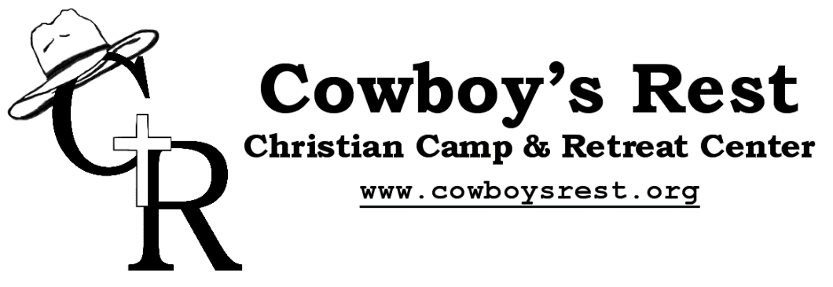

Psalm 116:7- Return, O my soul, to your rest; for the Lord has dealt bountifully with you.
So, what is Cowboy’s Rest? Cowboy's Rest is a non-denominational camp which exists to provide a Christian camping experience in a rustic, outdoor setting and to assist the local Church in encouraging and equipping her congregations.
How did Cowboy’s Rest begin? Cowboy’s Rest began as a vision in the hearts of our founders Bob and Chris Burrows. The Burrows and others in their church family had been organizing camping trips for children and quickly realized the need that today’s young people have to be in God’s creation. Many children were able to have their first experience sleeping in a tent, catching a fish, or shooting a .22 – and they loved it! They also loved the worship and teaching times around the campfire. God’s word seemed to penetrate their hearts more profoundly in a retreat setting, away from the busy schedules, technological distractions, and other pressures our children face today.
The Burrows became aware that northern Nevada was lacking in good camping facilities where churches could take their young people and do just what they had been doing. They began praying about buying some land to devote to these purposes. In August of 1995, Bob resigned his job as pastor of a nondenominational church in Fallon, Nevada, and moved the family to Elko, Nevada, so that he could work in the family produce business and look for a place to establish a camping ministry. After three and a half years of waiting on God, the door finally opened, and the Burrows were able to purchase the XJ Ranch. This property is located on Sherman Creek, below Sherman Peak at the south end of the beautiful Ruby Mountains. It is very isolated (60 miles from Elko), very peaceful, and very beautiful with wild turkeys, mule deer, elk, and horses roaming the property.
Cowboys Rest has been putting on camps since 1999 and many families and young people have devoted their time through prayer and service to the Vision of the Burrows family. Enabling thousands of campers to experience God’s creation first hand and grow in relationship with Him. The camp is now managed Brian and Dena Starkey who live out at the ranch full time taking care of the facilities and leading the staff.

What does Cowboy’s Rest believe? Cowboy's Rest is not connected to any one church or denomination. Our desire is to serve all members of the body of Christ who believe, as we do, that the Bible is the one and only, inerrant, written, revelation of God and that Jesus Christ is God incarnate and the only means and hope for man's salvation. Therefore, our desire is to foster an atmosphere wherein God’s goodness, purity, and love can be experienced by all.
Cowboy’s Rest has a more expansive Doctrinal Statement on the website along with a list of churches that have used our facilities or promoted our events.

How is Cowboy’s Rest Run? Policy decisions are made by a Board of Directiors which currently consists of 9 Christian men and their wives, including the Burrows and Starkeys who prayerfully consider and oversee all major policy, program, and facility decisions for Cowboy's Rest.

Where is Cowboy’s Rest Located? Cowboy's Rest is located 60 miles south of Elko, Nevada which is between Reno and Salt Lake City along I-80. The camp sits at 6,800 feet elevation and is located on the southern end of the majestic Ruby Mountains at the foot of Sherman Peak (10,300ft.).
Directions from Elko (I-80) and Eureka (U.S. 50) can be accessed on the website.

How is Cowboy’s Rest Funded? We are funded particialy by camper fees but camp stays affordable through donations. In 2017, 62% of costs were covered by faithful donations to the minisity. This allows for campers’ families to pay less than the actual cost of camp. ($210 for a 5 day camp in 2020)

What Facilities does Cowboys Rest offer?
Housing: The camp offers housing in the lodge, cabins, teepees, and wagons with roughly 92 beds for campers.
*New*: Cowboys Rest has just added a new triplex to provide more housing!
Bathhouses: The male and female bathhouses located near the pavilion each have 5 bathrooms with toilets, sinks, and showers.
Reservoir: Available for fishing, swimming, and boating, while also acting as home to our Iceberg, Flume, and Blob!
Pavilion: An outdoor dining and meeting area that can accommodate up to 120 guests where we host meals during summer camps.
Chapel: Our worship and meeting area equipped with lights and a sound system for meetings, music, and announcements. This is where chapel sessions are held during summer camps twice a day.
Campfire Area: A concreted area with a fire pit perfect for roasting marshmallows and singing songs.
Outdoor Chapel: An isolated meeting area up the canyon which can be accessed by the 1.8-mile Sunset Ridge trail or the road. Includes a campfire and male and female bathrooms.
Other facilites include: Basketball court, Gaga ball, Miniture golf, Challenge course, Climbing wall, Paintball course, Archery, Rifle range (22), Game room, and large fields perfect for all sorts of organized games.

Theme? For summer 2020 at Cowboys Rest our Hebrew keywork is melek, meaning “king”, “monarch” or “ruler.” As we dive into a study on the 2nd half of King David’s life we’ll explore two very important questions. First off; “Who wants to be Melek?” but more importantly, “Who is melek?”
For David, everyone around this monarch seemed to lay claim to his throne. His sons, his generals, his enemies -- nearly all of them desired to be king in David’s place. Even David himself occasionally acted as if he was the ultimate sovereign. Even he sometimes lost sight of the fact that another was truly Master.
The story of King David sheds light on our current lives. Everyone, at some point desires to be melek, to rule our own lives and dictate our own morality. But like David and his rebellious subjects, we must each learn that there is only one Melech ha-M’lachim -- only one King of kings. Jesus, the Anointed One, and someday He will reign supreme on the throne of His ancestor David.
So when you’re all out of lifelines, when you’ve used your last shoutout and the clock is out of time we must all answer the question, “Who is melek?” Jesus or me?
So brush up on your Bible Trivia and get ready to be a part of some real life game shows. Enough of watching them on TV, join us at Cowboy’s Rest this summer 2020 for all the buzzer beating answers, big prizes, spinning wheels, crazy puzzles and of course preposterous costumes!
How do I register for camp? Registration for 2020 camps opens on Febuary 1st and can be done online or through the mail. Individal registration information can be accessed on the Cowboy’s Rest website. Church groups can contact the camp and request a Group Registration Agreement.
With any other questions feel free to browse the website at www.cowboysrest.org or contact us via mail, phone or email;
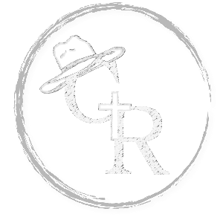
Cowboy's Rest Christian Camp
435 Jiggs Hwy Unit 4
Spring Creek, NV 89815
775.934.9806
775.397.0241 (Brian Starkey)
cowboysrest@hotmail.com
bstarkey@cowboysrest.org
Additional Contact Information;
Ezra Jones – Program Director
775.397.4980
cowboysrestprogram@gmail.com

