“Keep the Faith and the Faith will keep you”
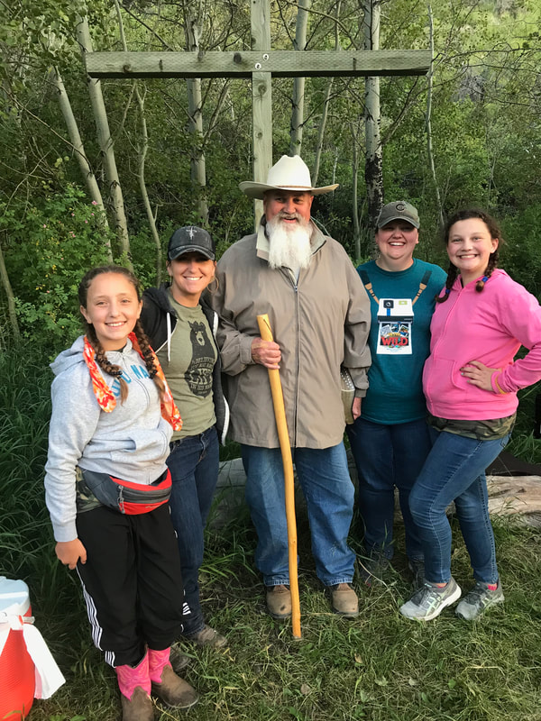
A devotional on Daniel 3 by Eddie Miller
Hardly anyone knows Hananiah, Mishael, and Azariah at least not by those names. They were three of the captive young men taken by the Babylonian King Nebuchadnezzar from Jerusalem in around 586BC. They had a friend named Daniel. He was responsible for one of the books in the Old Testament which bears his name. It’s in chapter three of that book that we find the story of these three smart, strong, faithful, and courageous men.
Ever felt captured? Ever felt peer pressure to just go along to get along? Ever thought to yourself, “I’ve really got myself in a mess now?” I have a feeling that these young men felt and thought all those things. You see their story is rather amazing. Their idol worshipping captors had seen their value as wise, young leaders. They had been elevated to positions of great responsibility in Babylon because of their giftedness. Even though they were captive they were helpful to the nation who held them. But there was a limit to their loyalty. They worshipped only one God, the true God, the God who created the world, called Abraham, raised up the Hebrew nation, gave them a land, punished them for their national sins, and got these young men to this point.
You see the king was rather full of himself and some of his followers convinced him he was a god. So, like every self-respecting god on the planet he wanted people to worship at his idol, a larger than life(90ft tall, 9ft wide) likeness of himself. When the music started, everyone was supposed to bow down and worship the idol he had made of himself. Well that’s where things sort of came apart, or you might say came together.
Hanania, Mishael, and Azariah more popularly known as Shadrach, Meshach and Abed-nego(even my spell checker knows them by those names) refused to bow and worship. Well old Neb got all worked up. These boys told him he might as well get on with the punishment. They had no intention of worshiping any other gods but their God. If He chose He could deliver them from the fire, but if He didn’t they intended to be faithful to their God and Him alone.
I guess by the time they finished talking old Neb was mad. He had the soldiers stoke the furnace extra hot, tied the Young Hebrews up, and threw these boys right into that fire. The soldiers who did the throwing died from the blast of the furnace. But that’s where things sort of went sideways on old Neb. In a moment, the folks gathered around to watch the execution and Nebuchadnezzar himself saw them just walking around there in the fire, but there was an extra person in there. Probably an angel in my opinion. Anyway, old Neb called the boys out of the fire and out they came not a hair singed, their clothes had not burned, they didn’t even smell like smoke. The only thing burned was the ropes that had bound them.
Even a hard headed and hard hearted king knows when he has seen God at work. Nebuchadnezzar made a decree that anyone who spoke against the God of Shadrach, Meshach, and Abed-nego would lose their lives for that action.
Just because you feel outnumbered, or overpowered always know if you do things God’s way, stand by your faith in Him, and just keep going God has a way to change any circumstance or change you through the circumstance.

